Practical 1: Understanding the basic computer network terminology and identification of various network-related components.

* **Connectors**
* **Cables**
* **Inter-Connecting Devices**

**Connectors**

**Registered jack connectors**

1).RJ32

* A registered jack is standardized telecommunication network interface for connecting voice and data equipment to a service provided by a local exchange carriers.
* This wiring provides a series tip and ring connection through the connecting block, but is used when the customer premises equipment is in series like automatic dialer.

2).RJ45

* It is a 8P8C connection connector used for 8 contacts.

1. T568A
2. T568B

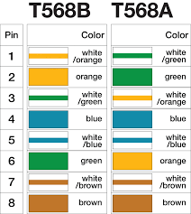

* These are the 2 types of wiring that can be done on either side of connector.
* If you connect A wiring with A , it is known as straight wiring & if opposite connection are matched then it is crossed connection by default.
* Only 1,2,3,6 lines are mainly used for these both connection types.

3).RS232

* Recommended standard 232 is a standard introduced in 1960s for seria communication transmission of data.
* RS232 maybe classified as data terminal equipment (DTE); this defines at each device which wires will be sending and receiving each signal.

4).BNC

* **Baynot neill-Concelman connector** is a miniature quick connector BFC used for coaxial cable.
* The BNC was originally designed for military use and has gained acceptance in video and RF applications upto 2GHz frequency.
* BNC connectors are made mostly in 50 or 70 ohm resistance.

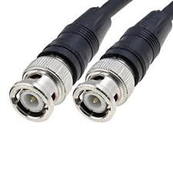

**Cables**

**1).Coaxial cable**

* A coaxial cable is a insulated copper cable used in computer networks. Also it is used to deliver cable TV services to users. It was first implemented in the early 1940s and is used for both baseband and broadband data communication services.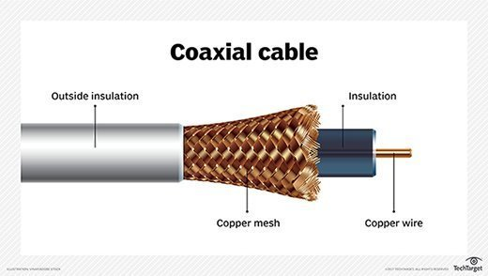
* A standard **coaxial cable** has two layers of **insulation**: the first, inner layer is referred to as the dielectric, and is located between a **cable's** center conductor and shield. ... Polyethylene, polypropylene and polyvinyl chloride (PVC) are among the most commonly used **insulation** materials.

Difference between cable shielding and cable insulation

* Cable **shielding** functions as an electromagnetic energy interceptor: it prevents electrical interference from traveling to the cable’s center conductor and disrupting the data signal.
* While **insulation** offers no protection against electromagnetic interference, it helps shielding to work effectively – and the cable as a whole to function properly – by keeping the center conductor and shield material from coming into contact with each other.

2).Twisted pair cable

* It is a type of wiring in which two conductors of a single circuit are twisted together for the purpose of improving electromagnetic compatibility.
* The main reason behind having this kind of wires was the noise or interference by electro-magnetic waves. The traditional cable can’t cancel out the magnetic field produced by same but opposite direction of data flowing very nearly from it. So the solution was twisted pair cable in which the two wires are twisted in such a way that noise will not be produced into the data.
* The pitch of the twist, usually defined in twists per meter: makes up part of the specification for a given type of cable. When nearby pairs have equal twist rates, the same wires of the different pairs may lie next to each other, partially not the benefits of differential mode. For this reason, it is commonly specified that, at least for cables containing small numbers of pairs, the twist rates must differ.
* In contrast to shielded or foiled twisted pair, UTP cable is not surrounded by any shielding. UTP is the primary wire type for telephone usage and is very common for computer networking.

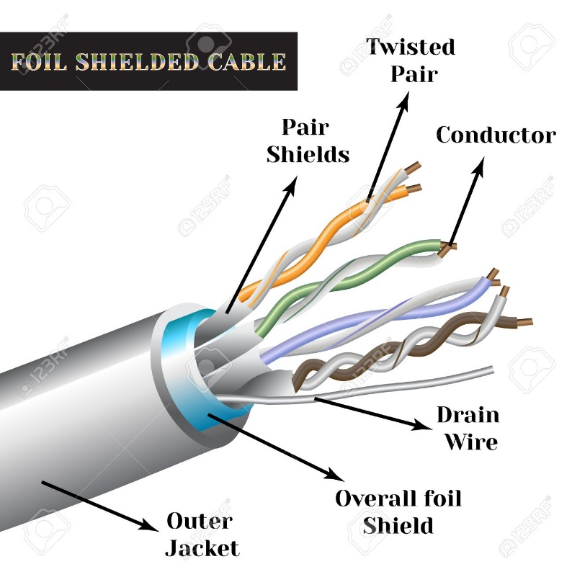

3).UTP

* Unshielded Twisted Pair are usually found in many Ethernet networks and telephone systems.
* In UTP, there is no shielding between twisted pairs and the outside of the foil.
* In an UTP cable, conductors are folded just like as of Twisted pair but they cancel out electromagnetic interference(EMI) from external sources. Unshielded means no additional shielding like meshes or aluminium foil, etc are used.
* UTP cables are just groups of twisted pairs put together with some kind of insulators, the number of which depends on the purpose of using it.

4).Optical Fibre Cable

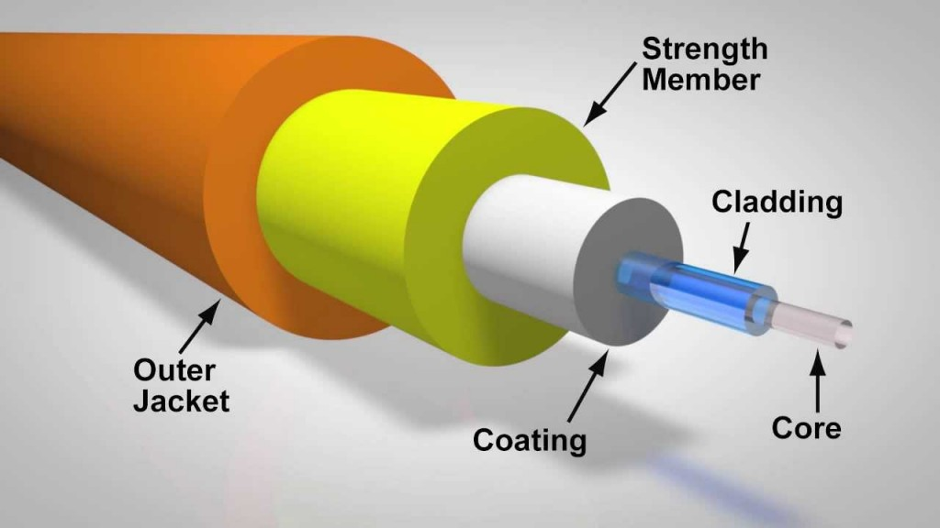

* It is an assembly to an electrical cable but containing one or more optical fibres that are used to carry light.
* Optical fibre consists of a core and a cladding layer, selected for total internal reflection(TIR) due to the difference in the refractive index between the two. In all cables the refractive index of core is (~1.5) higher than that of cladding (~1.2-1.3).
* In practical fibres, the cladding is usually coated with a layer of acrylate polymer or polyimide. This coating protects the fibre from damage but does not contribute to its optical waveguide properties.
* It is provided with more coating in terms of “coating”, “strength member”, “outer jacket”. It helps cable to work against any sudden & heavy mechanical pressure/force.
* Due to the high speed sending capability of the cable, it is used for large and safe data transfer.

HUB , SWITCH & ROUTER

* HUB and SWITCH both are similar type of devices. They are used to connect two or more devices with each other to create local area network(LAN).
* They are mostly used in organizations, institutes to connect all the PCs with internet.
* The hub is actually a dumb device because when it is used in network of computer systems, rather than sending a message to a particular pc with a MAC address, it simply transmits or send that data to all the computers in the system. It is a 1-layer device, only can understand the message is given to it, but can’t read the address of destination pc.
* Whereas switch is a 2-layer device, it understands the destination address of the pc as well & memorize the port through which that pc is connected & send data/signal only to that pc.
* So how it does that?
* Answer is it creates a table of port & MAC address of the pc connected at that port. So if one is sending data first time in system the table is not created yet so it’ll work as hub only but after each signal it memorize the source address & stores it in table in opposite of that particular port.
* A router is a networking device that forwards data packets between computer networks. Routers perform the traffic directing functions on the Internet. Data sent through the internet, such as a web page or email, is in the form of data packets. A packet is typically forwarded from one router to another router through the networks that constitute an internetwork until it reaches its destination node.
* Router also creates a memory about the devices that are connected to the left part of it, as well as of right side of the router.so when we download something through internet, the IP address of the particular pc from where we want to download something is at right side, so packets will come from outer world to left side & while uploading its vice-versa.

**Thank You!**